Installation of CashFlow 4.0 Application

Steps | Activity
- Double click the “Team Antolin” folder | 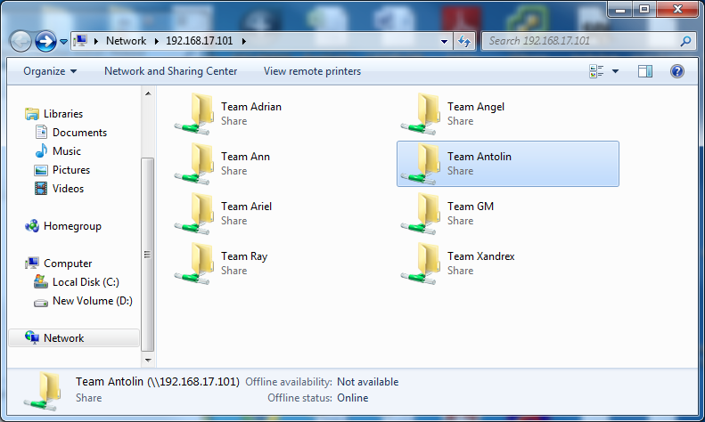
- Double click the “Cashflow4.1” folder | 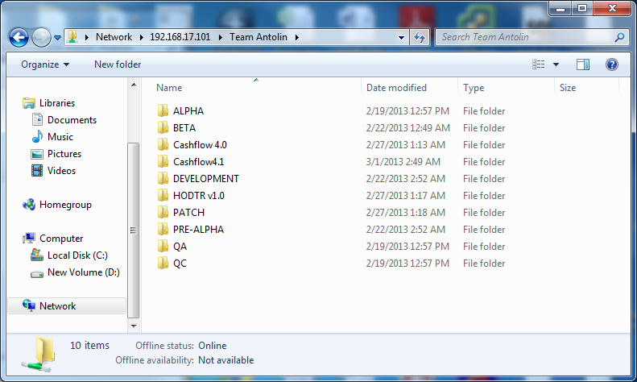
- Double click the “QC” folder | 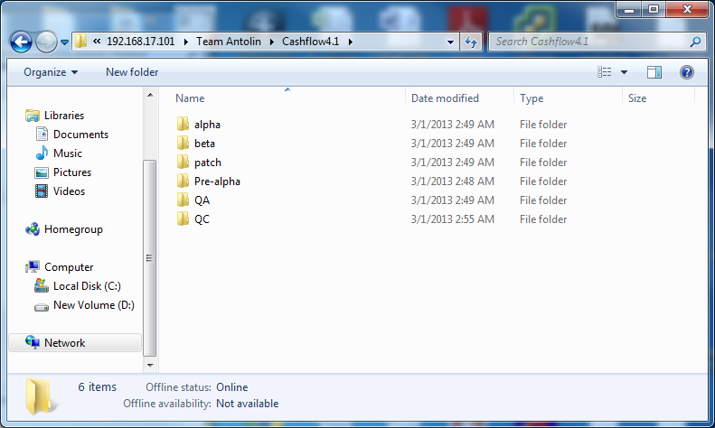
- Double click the “CashFlowVersion4.1 Installer” folder | 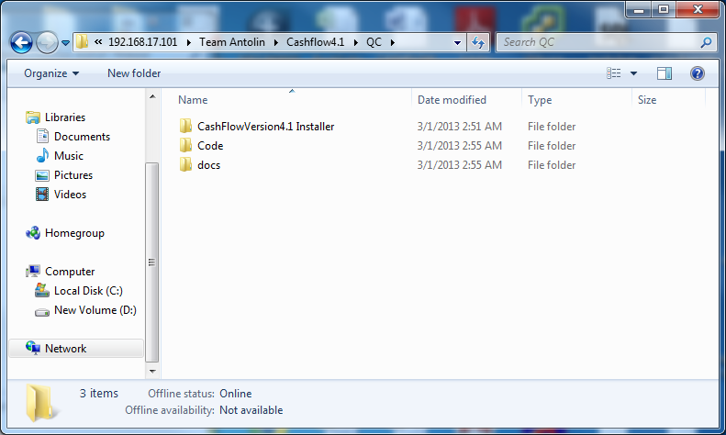
- Double click the “Debug” folder | 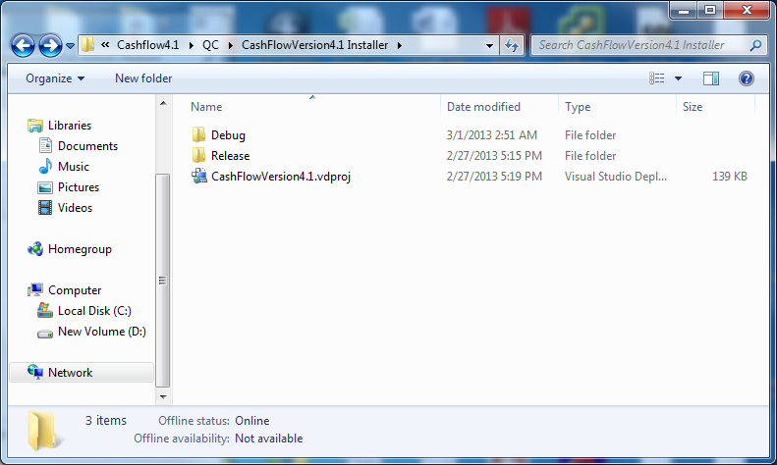
- Double click the “setup.exe” | 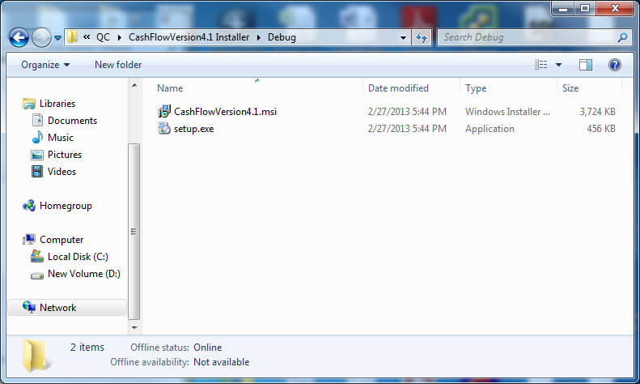
- Click the Run button | 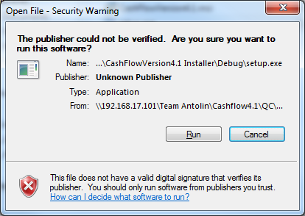
- Click “Next” | 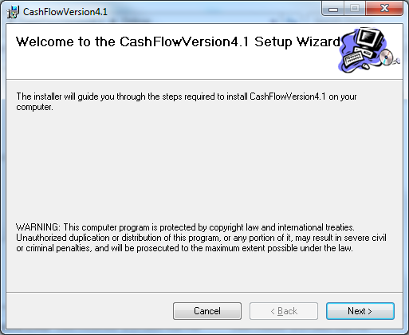
- Choose “Everyone” and then click “Next”. | 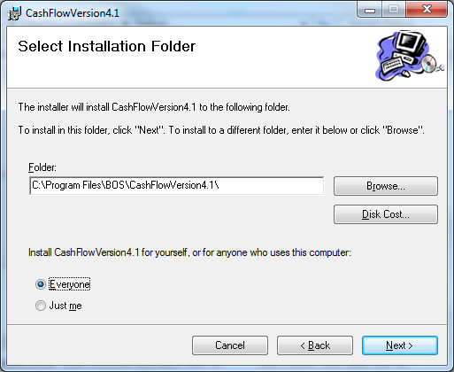
- Click “Next” | 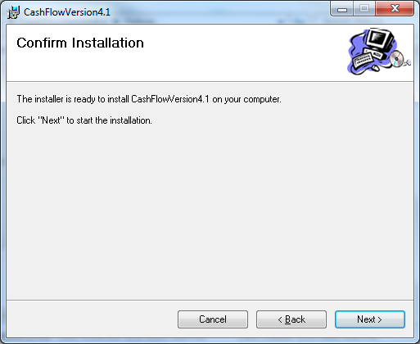
- Click “Close” to finish installation. | 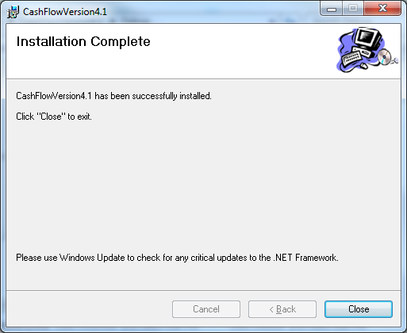
- Go to “”Drive C”
- Click “Program Files”
- Double Click folder “BOS”
- Inside the folder “BOS”, open folder “CashFlowVersion4.1”
- Double click the icon named CashFlowVersion4.exe” | 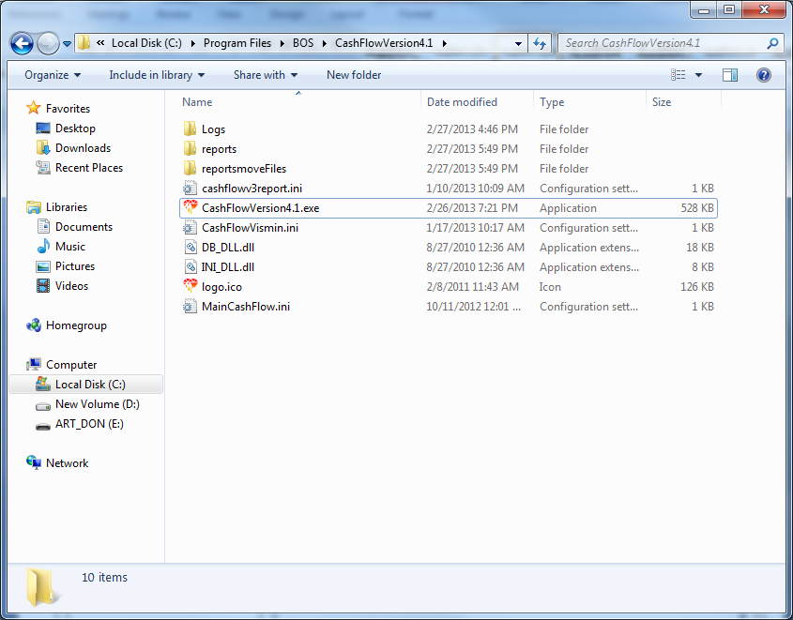
- Done

